Data Visualization Lab 6: Advanced Power BI Visual Analytics
Student Name: M. Umar Shafiq
Roll # BSDSF24A050

Page 1: Sales Comparison Dashboard

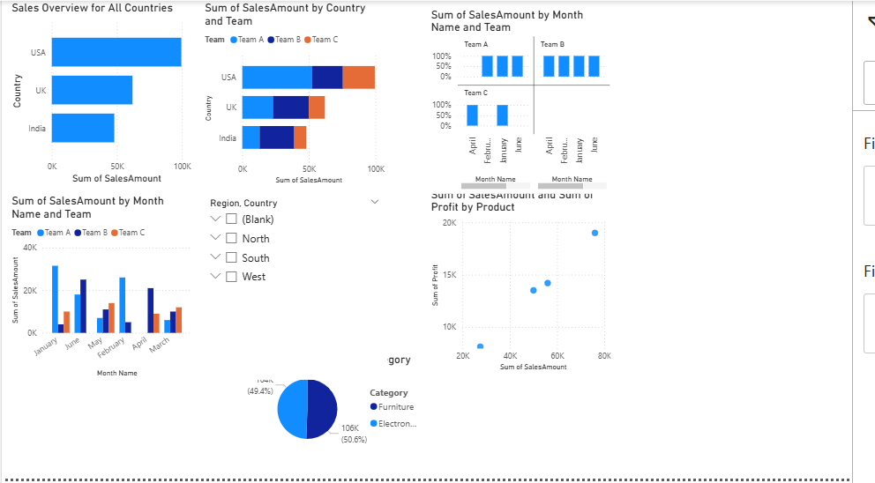

Key Findings:
Looking at the high-level bar chart, the USA is our strongest market by a significant margin, with the UK coming in second. When I used the drill-down feature to look closer at the team dynamics within these countries, Team A consistently brings in the most revenue. The small multiples visual was particularly useful here; it showed me that while some teams have highly volatile sales months, the overall company revenue stays relatively stable because other teams compensate for those dips.

Page 2: Trend and Composition Analysis

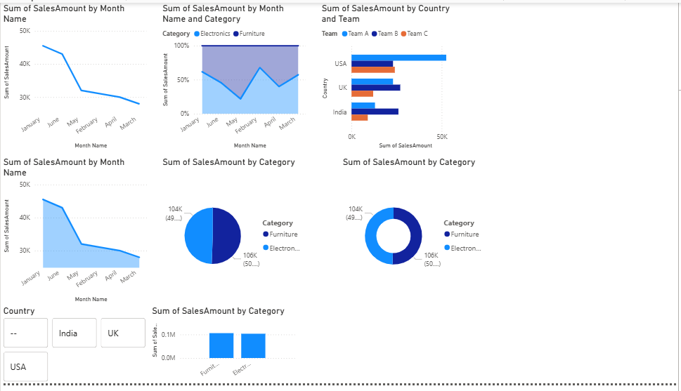

Key Findings:
The area and line charts map our sales over the year, showing distinct seasonal peaks and valleys. Looking at the composition (pie and donut) charts, the "Electronics" category—specifically driven by Laptops—makes up the largest portion of our overall sales. Corporate clients are our biggest customer segment, which explains the high volume of bulk electronics and furniture orders.
Note on Chart Selection: As requested in the lab, I created an intentional "incorrect" line chart using 'Product' on the x-axis. This visually demonstrates why line charts shouldn't be used for categories; the connecting line implies that a "Mouse" slowly turns into a "Laptop," which makes no logical sense.

Page 3: KPI Dashboard

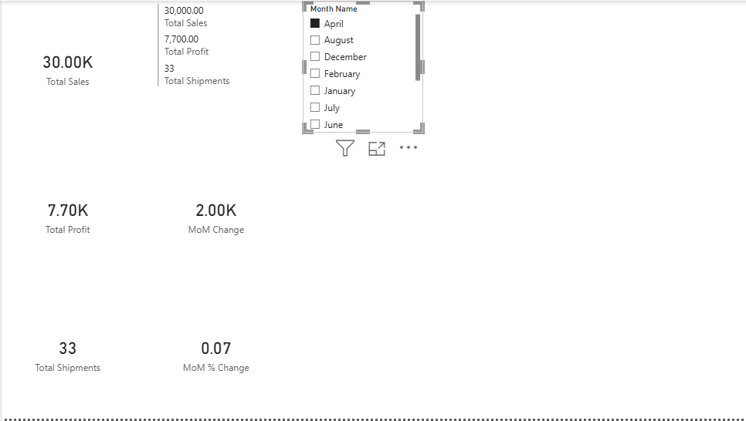

Key Findings:
This page acts as an executive summary. The total numbers for Sales, Profit, and Shipments are healthy, but the real insight comes from the Month-over-Month (MoM) percentage change. For instance, even if total sales look high in a given month, the MoM indicator quickly highlights if we actually underperformed compared to the previous month. This gives management immediate context rather than just raw numbers.

Page 4: Detailed Analysis

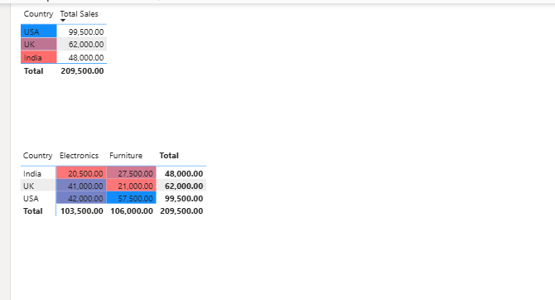

Key Findings:
This page breaks down the granular details. By adding green data bars directly into the table, my eyes are immediately drawn to our top performers, like John in the USA and Alice in the UK, who are moving our most expensive inventory. The matrix visual acts like a heat map due to the conditional formatting. It instantly highlights that the USA dominates the Furniture category (darkest green), while India struggles with lower sales numbers across most product lines (highlighted in red).

Page 5: Advanced Analysis

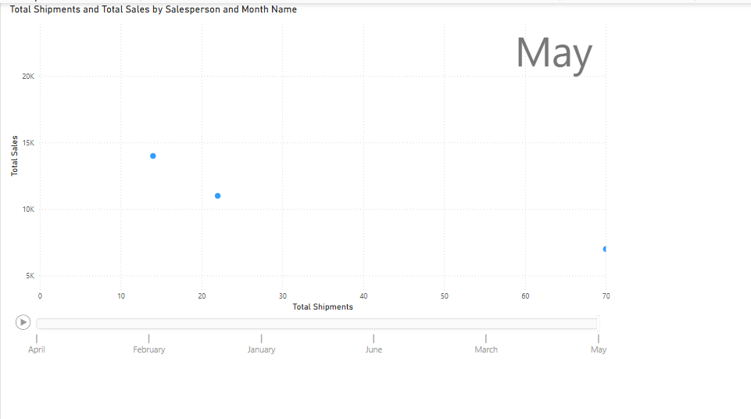

Key Findings:
The scatter plot mapping Shipments (X-axis) against Sales (Y-axis) revealed some interesting outliers among the sales team. For example, during certain months, we have salespersons who processed a massive number of shipments, but their total sales revenue stayed relatively low (indicating they were mostly selling cheap items like mice). Conversely, a few dots sit high on the Y-axis but low on the X-axis, representing salespeople who closed just a few deals, but they were massive, high-ticket corporate orders.

Page 6: Contribution Analysis

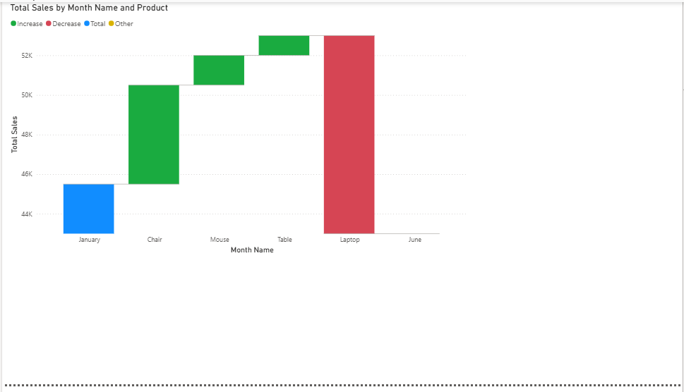

Key Findings:
The waterfall chart is incredibly helpful for understanding exactly how we got from our January sales totals to our June sales totals. Instead of just seeing the net difference, the breakdown by Product shows the specific drivers. I can clearly see which products dragged our revenue down (the red downward bars) and which products surged to keep the final June numbers afloat (the green upward bars).

Page 7: Tooltip Page Enhancement

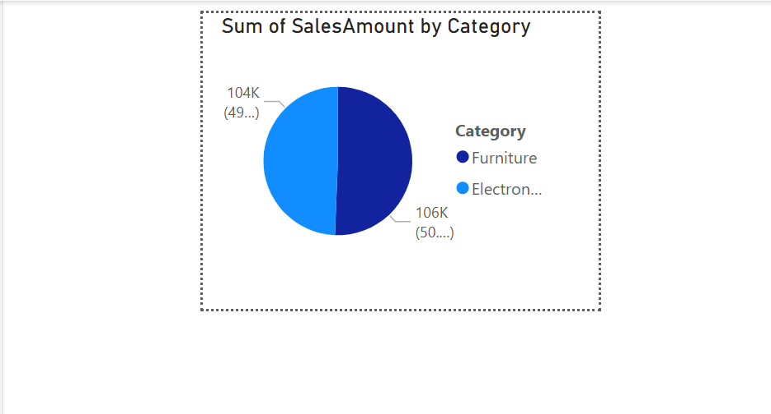

Key Findings:
To avoid cluttering the main dashboard with too many visuals, I built a custom tooltip page. Now, when a user hovers their mouse over a specific Country on the main bar chart, a small pie chart dynamically appears, showing exactly how that specific country's sales are divided between Electronics and Furniture. It makes the report highly interactive and saves valuable screen space.

Analytical Questions
- Why should line charts use time-based axes?
Line charts use lines to connect data points, which visually implies a continuous journey, trend, or progression. It only makes sense to connect points when showing how a specific metric moves sequentially through time.
- Why are pie charts ineffective with many categories?
Human brains aren't naturally good at comparing the sizes of angles or pie slices just by glancing at them. When a pie chart has too many categories, it turns into a messy wheel of tiny, similarly-sized slivers.
Why are KPI cards incomplete without context?
A standalone number on a KPI card doesn't really tell a story. If a card just says "Total Sales: $100,000", a stakeholder doesn't know how to react. Is that a record-breaking high, or is it a terrible drop from last month? By adding context—like a target goal, or a month-over-month percentage change—the number becomes actionable because you instantly know if the business is doing well or failing.
- How do scatter plots help identify outliers?
Scatter plots graph every individual data point across two different numeric metrics (X and Y axes). Because of this, normal, expected behavior tends to naturally clump together into a big cluster in the middle of the graph.
Why is drill-down important in dashboards?
Dashboards are supposed to be clean and easy to digest at a glance. If you try to show every single detail (like the sales of every single team in every single country) all at once, the screen becomes an unreadable mess of tiny bars.

